

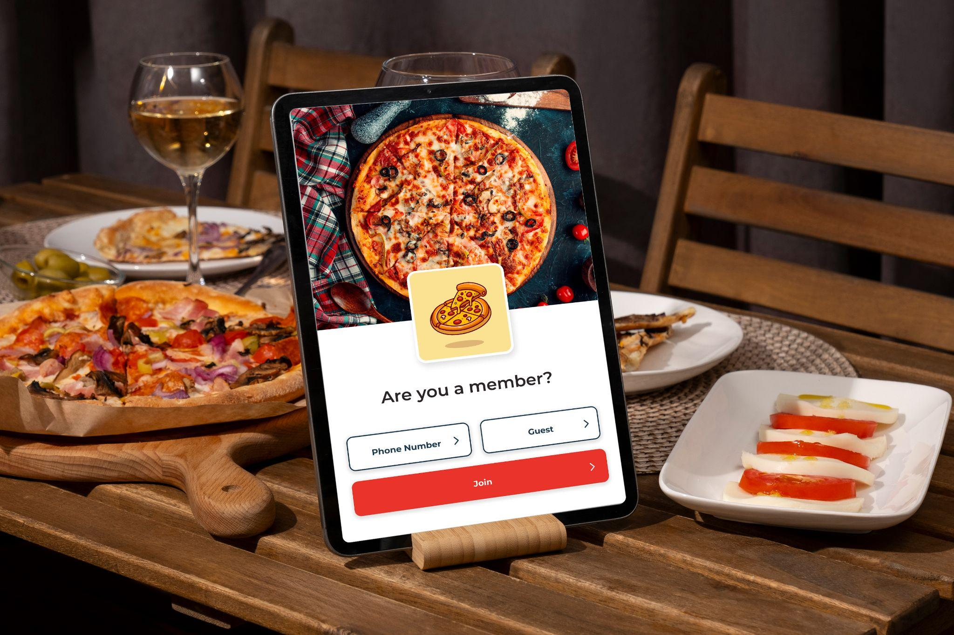

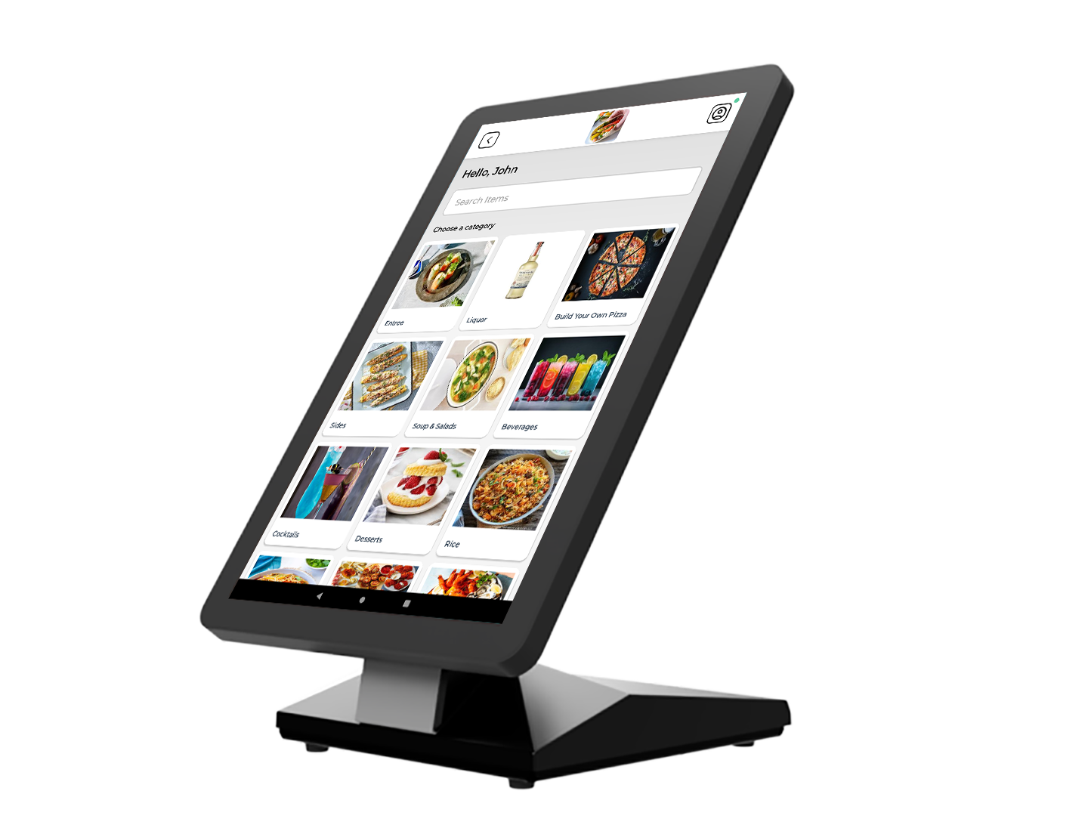

**Self Ordering**

**Feature List**

**Table of Content**

Login 3

Customer Management 3

Menu Management 3

Inventory Management 3

Supported Service Areas 3

Discount Management 4

Kitchen Ticket Management 4

Tips Management 4

Payment Programs 4

Payments 4

Integrations (Payment Processors) 4

Supported Printer 4

|  | Login |
| --- | --- |

| * As Guest (with name) * Phone number (using the registered one) | * Join a new member (phone number mandatory only) |
| --- | --- |

|  | Customer Management |
| --- | --- |

| * View/edit customer details * Check previous orders | * Reorder from Previous Order |
| --- | --- |

|  | Menu Management |
| --- | --- |

| * Easy-to-Build Menus (from backend) * Color-Coded Menus * Items with Force Mod * Items with Free Mods * Multi Selectable Mods * Included Mods and Free Mods combination * Pre and Post Mods * Hide Category/Item (from the backend) * Terminal-Based Menu | * Display Items with Images and Descriptions * Categories and Subcategories Supported * Meal Period-Based Menu * Centralized Menu Management (from the backend) * Customize the Number of Columns * Pre/Post and Pizza Topping * Combo Item * Idle Screen Timeout |
| --- | --- |

|  | Inventory Management |
| --- | --- |

| * Track Inventory (setup from backend) * Out of Stock when not available | * Set Item Count for Specials (set up from the backend) |
| --- | --- |

|  | Supported Service Areas |
| --- | --- |

| * Quick Serve * Custom Fields (Service area specific) | * Takeout |
| --- | --- |

|  | Discount Management |
| --- | --- |

| * Time-Based Promotions (Happy Hour) * Redeem Coupon | * Redeem Points (Loyalty) |
| --- | --- |

|  | Kitchen Ticket Management |
| --- | --- |

| * Send to Kitchen on Pay (Card pay) * Item and Modifier display on Ticket | * Special Instructions via Order Note and Item Note |
| --- | --- |

|  | Tips Management |
| --- | --- |

| * Custom Tip (Amount only) | * Predefined Tips Support (Setup from the backend) |
| --- | --- |

|  | Payment Programs |
| --- | --- |

| * Cash Discount | * Dual Pricing |
| --- | --- |

|  | Payments |
| --- | --- |

| * Cash (Payable on the POS, can hide on Kiosk) * Gift Cards (Manual/Swipable on PAX only) * Share Receipt (via Email or Text) | * Card (Payable on the attached Pax Direct) * Print Receipt |
| --- | --- |

|  | Integrations (Payment Processors) |
| --- | --- |

| * Direct PAX | * UK Payment Gateway (PAX) |
| --- | --- |

|  | Supported Printer |
| --- | --- |

| * Epson TM-M30 (Ethernet and USB) | * Epson TM-U220B |
| --- | --- |

|  | |
| --- | --- |



# 

**Thank You for**

**Choosing Quantic**

We’re a digital toolbox. We help you grow

and manage your business.

*getquantic.com*